Lab Report7

Yen-Jung(Tim) Lu, Xingting Peng

1. Include an introduction, circuit diagrams and Verilog code from the prelab and lab.

Introduction:

In this lab, students will learn how to use a comparator and counter in a circuit. Students would utilize comparators and counters to create a slot machine which would show win or lose as the user pressed and released the button. Students would also need to write the verilog code for *spec_7seg* and the *my_status _code* to display the status on the circuit board.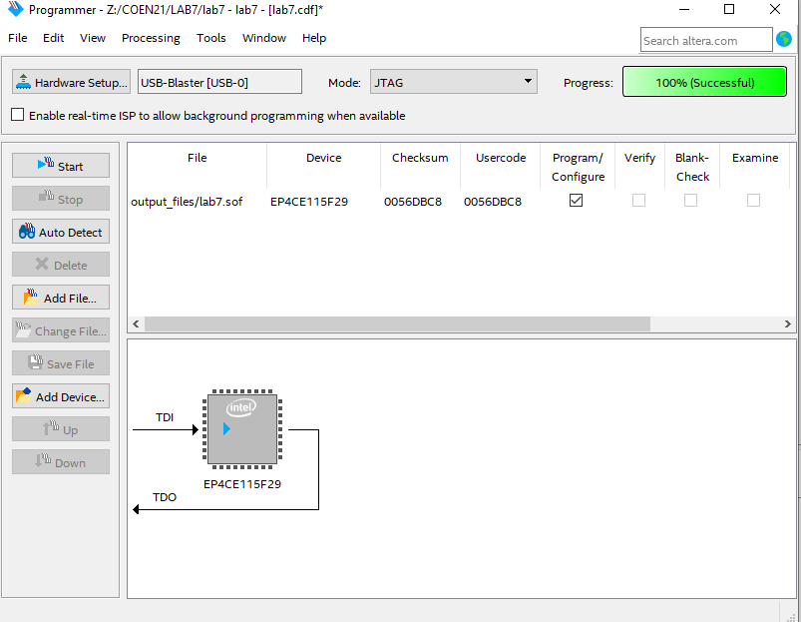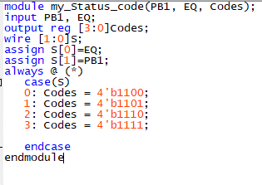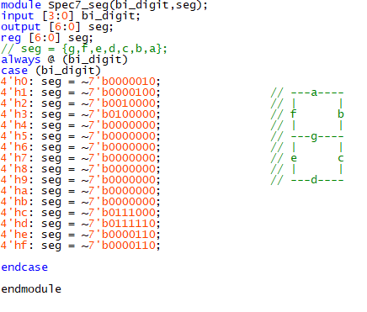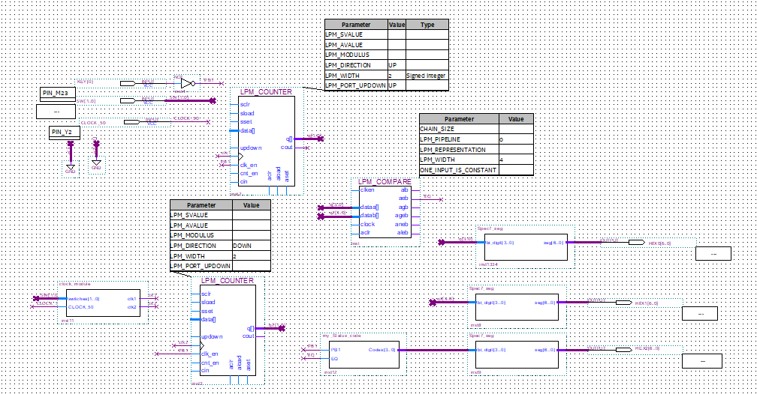

2. How often were you able to win using each mode? Include a photo of your board for both a win and a loss.

We were able to win seven times with the slower speed and win three times with the faster speed.

|  | slow | fast |
| --- | --- | --- |
| 1 | lose | lose |
| 2 | win | win |
| 3 | lose | lose |
| 4 | win | lose |
| 5 | lose | lose |
| 6 | lose | lose |
| 7 | win | win |
| 8 | win | lose |
| 9 | lose | lose |
| 10 | lose | win |

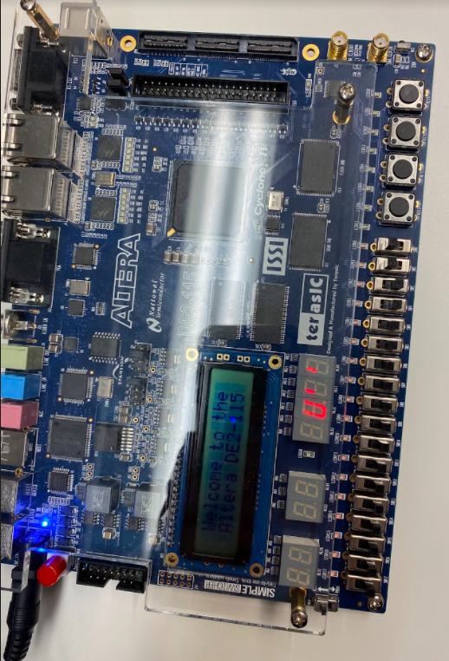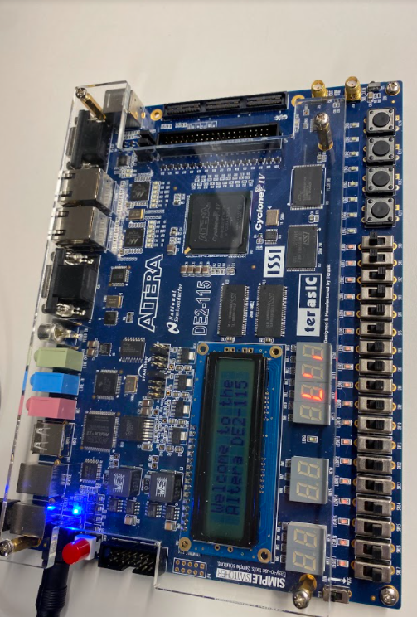

3. From the prelab, which form of the Verilog module my_status_code was the easiest or most intuitive for you? Explain briefly.

In the prelab, it is easier to write the verilog module my_status_code with the if-else statements, because we can easily compose the code by setting up the statement of EQ.

4. If you want to use 8 symbols instead of only 4 to make it harder to win the game, list all the things you would need to change.

* Verilog module of *spec_7seg*
* Verilog module of *my_status code*
* Numbers of counters utilized in the schematic
* Numbers of comparator used in the schematic